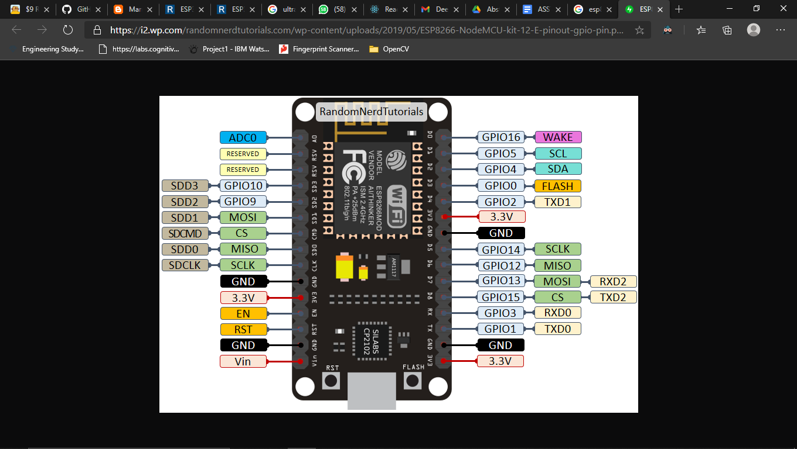

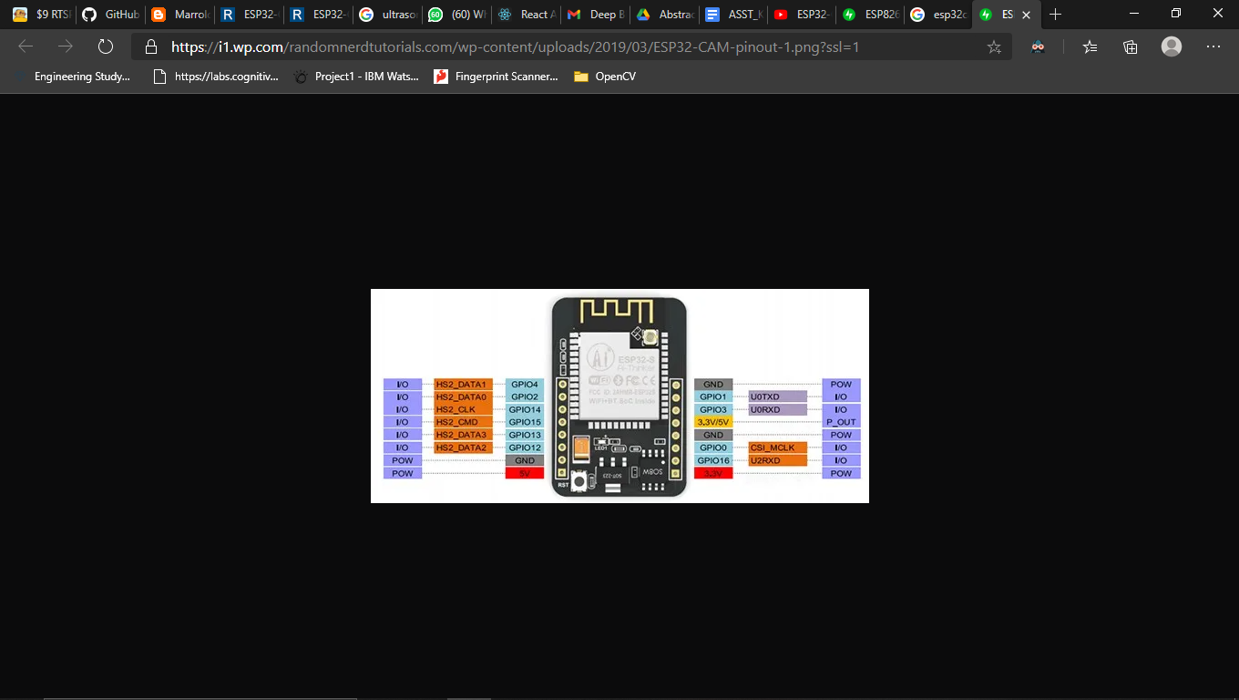

[$9 RTSP Video Streamer Using the ESP32-CAM Board : 3 Steps - Instructables](https://www.instructables.com/9-RTSP-Video-Streamer-Using-the-ESP32-CAM-Board/)

[ESP32-CAM PIR Motion Detector with Photo Capture | Random Nerd Tutorials](https://randomnerdtutorials.com/esp32-cam-pir-motion-detector-photo-capture/)

[ESP32 I2C Communication: Set Pins, Multiple Bus Interfaces and Peripherals | Random Nerd Tutorials](https://randomnerdtutorials.com/esp32-i2c-communication-arduino-ide/)

Wire.begin(I2C_SDA, I2C_SCL);

#define I2C_SDA 33

#define I2C_SCL 32

[How can I have I2C based devices running on ESP32-CAM? : esp32 (reddit.com)](https://www.reddit.com/r/esp32/comments/eq14zn/how_can_i_have_i2c_based_devices_running_on/)

[ESP32-CAM Ping Ultrasonic Sensor - YouTube](https://www.youtube.com/watch?v=zO7V2PiOhCI)

[Arduino/ESP32-CAM_UltrasonicSensor.ino at master · fustyles/Arduino · GitHub](https://github.com/fustyles/Arduino/blob/master/ESP32-CAM_UltrasonicSensor/ESP32-CAM_UltrasonicSensor.ino)

The framesize must be CIF ,QVGA, HQVGA, QQVGA

Trig pin -> ESP32-CAM IO 2

Echo pin -> ESP32-CAM IO 13

[Temperature based Touchless Attendance System using NodeMCU and MLX90614 Infrared Thermometer (iotdesignpro.com)](https://iotdesignpro.com/projects/temperature-based-touchless-attendance-system-using-nodemcu-and-mlx90614-infrared-thermometer)

<https://www.esp8266learning.com/mlx90614-infrared-thermometer-example.php>

<https://iotdesignpro.com/projects/temperature-based-touchless-attendance-system-using-nodemcu-and-mlx90614-infrared-thermometer>

*VIN -> Wemos 3.3v  
GND -> Wemos GND  
SCL -> Wemos D1  
SDA -> Wemos D2*

[*https://www.instructables.com/Interface-LCD-Using-NodeMCU/*](https://www.instructables.com/Interface-LCD-Using-NodeMCU/)

**GND** pin of I2C is connected Ground pin (**GND**) of the NodeMCU.

**VCC** pin of I2C is connected **Vin** pin of the NodeMCU. (Because we need to supply 5v to LCD)

**SDA** pin of I2C is connected **D4**of the NodeMCU.

**SCL** pin of I2C is connected**D3**pin of the NodeMCU.

[Ultrasonic sensor interfaced with nodemcu esp8266 12e for distance measurement (engineersgarage.com)](https://www.engineersgarage.com/esp8266/distance-measurement-with-hcsr04-and-nodemcu/)

const int trigP = 2; //D4 Or GPIO-2 of nodemcu

const int echoP = 0; //D3 Or GPIO-0 of nodemcu

[flask-firebase-admin · PyPI](https://pypi.org/project/flask-firebase-admin/)

[Flask API Authentication with Firebase | by nschairer | Medium](https://medium.com/@nschairer/flask-api-authentication-with-firebase-9affc7b64715)

[ESP8266 NodeMCU HTTP GET and HTTP POST with Arduino IDE | Random Nerd Tutorials](https://randomnerdtutorials.com/esp8266-nodemcu-http-get-post-arduino/)

[ESP8266: Parsing JSON : 4 Steps - Instructables](https://www.instructables.com/ESP8266-Parsing-JSON/)